**22AIE214 – INTRODUCTION TO ROBOTICS**

**LABSHEET 4**

Name : Anuvind M P

Roll no : AM.EN.U4AIE22010

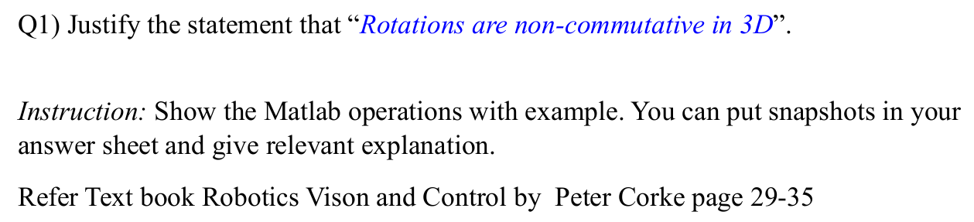

**CODE :**

Rx = rotx(45, 'deg');

Ry = roty(90, 'deg');

R1 = Ry * Rx;

R2 = Rx * Ry;

disp('Rotation matrix R1 (Ry * Rx):');

disp(R1);

disp('Rotation matrix R2 (Rx * Ry):');

disp(R2);

isEqual = isequal(round(R1, 10), round(R2, 10));

disp('Are the rotation matrices equal?');

disp(isEqual);

figure;

subplot(1,2,1);

trplot(R1, 'frame', 'R1', 'color', 'r');

title('Rotation: Ry * Rx');

subplot(1,2,2);

trplot(R2, 'frame', 'R2', 'color', 'b');

title('Rotation: Rx * Ry');

end

**Justification :**

Rotations in 3D are non-commutative, meaning the order in which rotations are applied matters. This can be mathematically demonstrated using rotation matrices. For instance, rotating first about the x-axis and then the y-axis yields a different result than rotating first about the y-axis and then the x-axis. Physically, imagine rotating a book 90 degrees around the x-axis and then 90 degrees around the y-axis, and compare this to doing the rotations in the reverse order—the book ends up in different orientations. Thus, both mathematical representation and physical experiments show that 3D rotations do not commute.

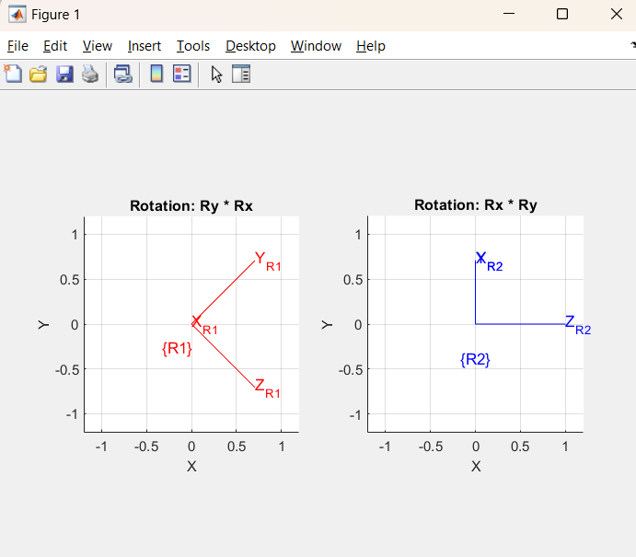

**OUTPUT :**

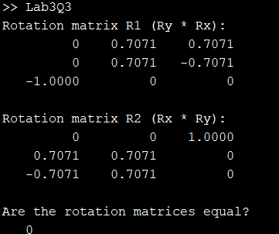



**CODE :**

vx = 1; % Translational velocity in x

vy = 2; % Translational velocity in y

omega = pi/6;

dt = 1;

theta = omega * dt;

R = [cos(theta), -sin(theta); sin(theta), cos(theta)];

t = [vx * dt; vy * dt];

T = [R, t; 0, 0, 1];

% Display the result

disp('Homogeneous transformation matrix T:');

disp(T);

% a point in homogeneous coordinates

point = [1; 1; 1];

transformed_point = T * point;

disp('Transformed point:');

disp(transformed_point);

end

**OUTPUT :**

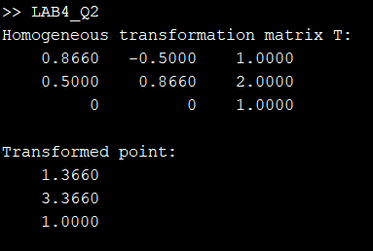

**CODE :**

T0 = eye(4);

theta = pi/2;

R = trotz(theta);

T1 = R;

figure;

axis([-1 1 -1 1 -1 1]);

view(3);

grid on;

hold on;

trplot(T0, 'frame', '0', 'color', 'b', 'arrow', 'length', 0.5);

title('Rotation Animation using tranimate');

tranimate(T0, T1, 'frames', 50, 'rgb');

trplot(T1, 'frame', '1', 'color', 'r', 'arrow', 'length', 0.5);

hold off;

end

